# Results and Discussion

The mRMR algorithm produces a sequential list of ten ranked features that exhibit maximum dependency to the diabetic class, Table 2. Besides ethnicity (ranked as fourth feature), all other features are rather deduced form the concentration measurements. Six out of 10 most relevant features deduced from glucose concentrations, while only three features are deduced form insulin concentrations.

Table 2: List of ten most relevant features ranked by the mRMR algorithm

|  |  |
| --- | --- |
| Rank | Feature |
| 1 | AuC-Glu0-120 |
| 2 | ΔGlu120-0 |
| 3 | ΔGlu120-60 |
| 4 | ETHN |
| 5 | ΔIns120-0 |
| 6 | ΔGlu60-0 |
| 7 | ΔGlu30-0 |
| 8 | ΔGlu60-30 |
| 9 | ΔIns120-60 |
| 10 | ΔIns60-0 |

In all the classification experiments, we aimed to maximize the ability to correctly predict the diabetic class. The bar plots (Fig. 3-left) show the geometric mean (g-mean) of the sensitivity and specificity obtained from the linear and RBF kernels. For each number of features used, we selected the combination that generated the maximum g-mean. All the results presented here are averaged over 100 iterations of the respective classifiers. The accuracy and specificity of the best feature combinations are illustrated separately in Fig. 3-right.

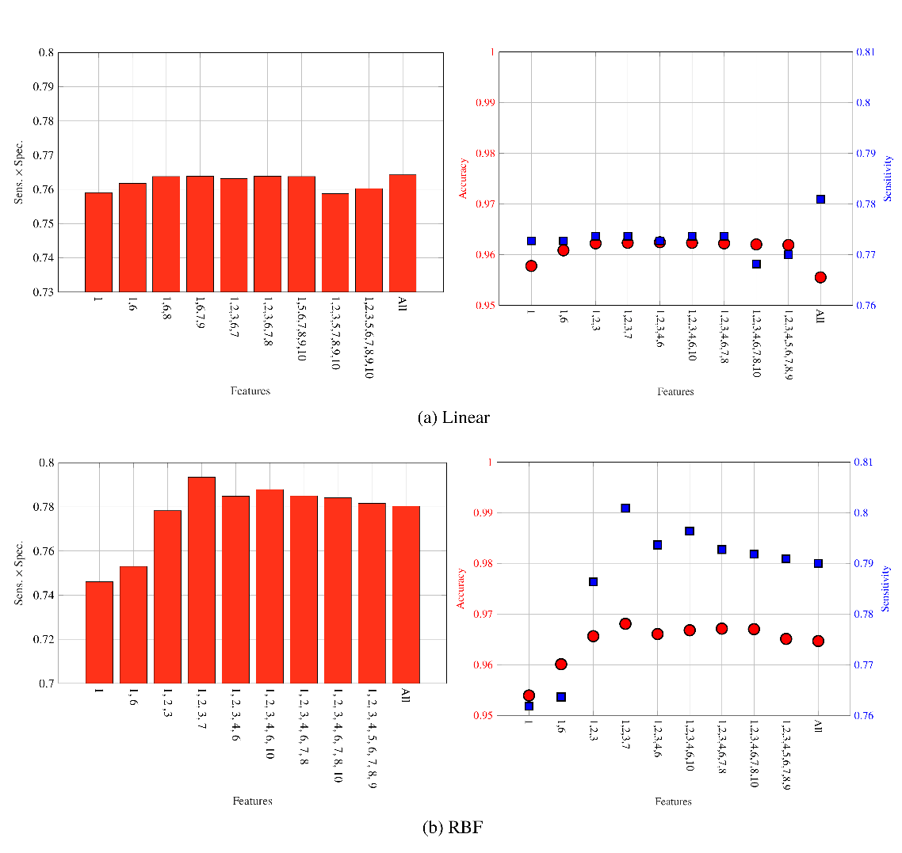

Figure 3: Geometric mean of sensitivity and specificity, and performance in terms of accuracy and sensitivity for the best feature combinations

As illustrated in Fig. 4 , the g-mean for linear SVM ranges from xx to yy, and for non-linear SVM from xx to yy. More observations from Fig. 4… A combination of four features, namely AuC-Glu0-120, ΔGlu120-0, ΔGlu120-60 and ΔGlu30-0 provided the best classification performance using a non-linear SVM: g-mean of 0.89, accuracy of 96.8 %, and sensitivity of 80.5.

Table III presents a comparison of the generated SVM models to the results obtained in other studies using the SAHS dataset. We compared our results with the San Antonio diabetes prediction model (SADPM) [15], in which age, gender, ethnicity, fasting glucose level, family history, blood pressure, and cholesterol level were used to construct a logistic regression. It is notable that the SADPM has a reasonable sensitivity (88.8%), however this increased prediction performance comes along with a very low accuracy of only 56.3%. In [16], a two-step approach was introduced that first used the SADPM risk score and then augmented it with the 1-hour blood glucose level. This strategy resulted in an improved accuracy but the sensitivity dropped to 77.7%

Table 3 also reveals that out of those subjects, diagnosed with prediabetes according to the WHO IGT criteria at baseline, only 33.93% actually developed diabetes between the baseline and the follow-up. Moreover, only 8.19% of the subjects were diagnosed with diabetes that matched one of the diagnostic criteria defined by the American Diabetes Association (ADA).

Table 3: Validation performance of the best SVM classifiers

* is current standard of care [REF] to diagnose T2DM

|  |  |  |  |
| --- | --- | --- | --- |
|  | Accuracy ± SD | Sensitivity ± SD | Specificity ± SD |
| Linear SVM | 96.20 % ± 1.94 % | 77.00 % ± 12.08 % | 98.75 % ± 1.35 % |
| SVM-RBF | 96.81 % ± 1.40 % | 80.45 % ± 11.50 % | 100 % |
| SADPM [15] | 56.329 % | 88.80 % | 52.00 % |
| Two-step Approach [16] | - | 77.70 % | 77.40 % |
| IGT (PG120 > 140 & <200 mg/dL)* | - | 33.93 % | - |
| ADA Criteria (PG120 > 200 mg/dL)* | - | * 1. % | - |

# Conclusion

In this paper, we present a most promissing set of features that are used to develop a non-linear SVM based future T2DM prediction model. The features were derived from the OGTT data and were augmented by age, …. Using a feature selection algorithm, we demonstrate that the features that are deduced from the blood glucose concentrations have the strongest predictors of the future development of T2DM. Moreover, the performance of the presented prediction model is significantly better in terms of accuracy and sensitivity, as compared to other T2DM prediction schemes. In order to address the unbalanced nature of the SAHS dataset, we chose the geometric mean of sensitivity and specificity as the performance evaluation criteria.

The principal contribution of this study includes a T2DM prediction model based on the features derived only from the blood glucose concentrations measured during an OGTT. This model significantly outperforms previously published models [REF]. The findings of this paper can provide a tool for the clinicians to screen individuals that are at an increased risk of developing T2DM in future.